**Student Name : Santosh Acharya**

**Student Id : C0930325**

**Program Code : CSD 2206**

**Assignment 6**

**Solution**

**1. Produce a list of all customer names in which the first letter of the first and last**

**names is in uppercase and the rest are in lowercase.**

* SQL query use the Select statement to retrieve the data from the table. Select is use to select the data from the database.
* INITCAP will return the first letter of the character in the upper case and remaining in the lower case.
* SUBSTR is use to extract the sub-string from the string. And it required three parameter string, start and length.

**SQL query**

* SELECT INITCAP(firstname) AS santosh_Firstname, INITCAP(lastname) AS Lastname from customers where SUBSTR(firstname, 1, 1) = UPPER(SUBSTR(firstname,1,1)) AND SUBSTR(lastname,1,1)= UPPER(SUBSTR(lastname,1,1));

**ScreenShot of the SQL**

Output

SQL Query

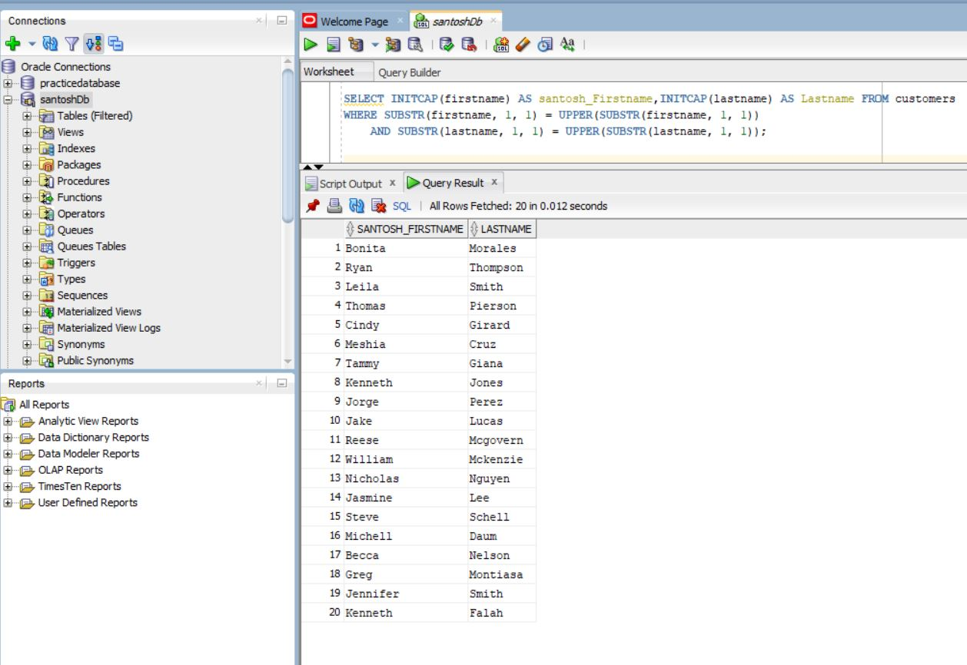

**2. Create a list of all customer numbers along with text indicating whether the customer**

**has been referred by another customer. Display the text “NOT REFERRED” if the**

**customer wasn’t referred to JustLee Books by another customer or “REFERRED” if**

**the customer was referred.**

* Case is the expression used in SQL which will go through certain condition and return the first condition it met while running the SQL
* IS NULL is use to determine whether the value is null or not in the table.
* THEN and ELSE are used as similar as IF-ELSE condition.

**SQL Query**

* SELECT customer#,firstname as santosh_firstname,lastname,CASE WHEN referred IS NULL THEN 'NOT REFERRED' ELSE 'REFERRED' END AS ReferralStatus FROM Customers;

**Screen Shoot Of the SQL query**

Output

SQL Query

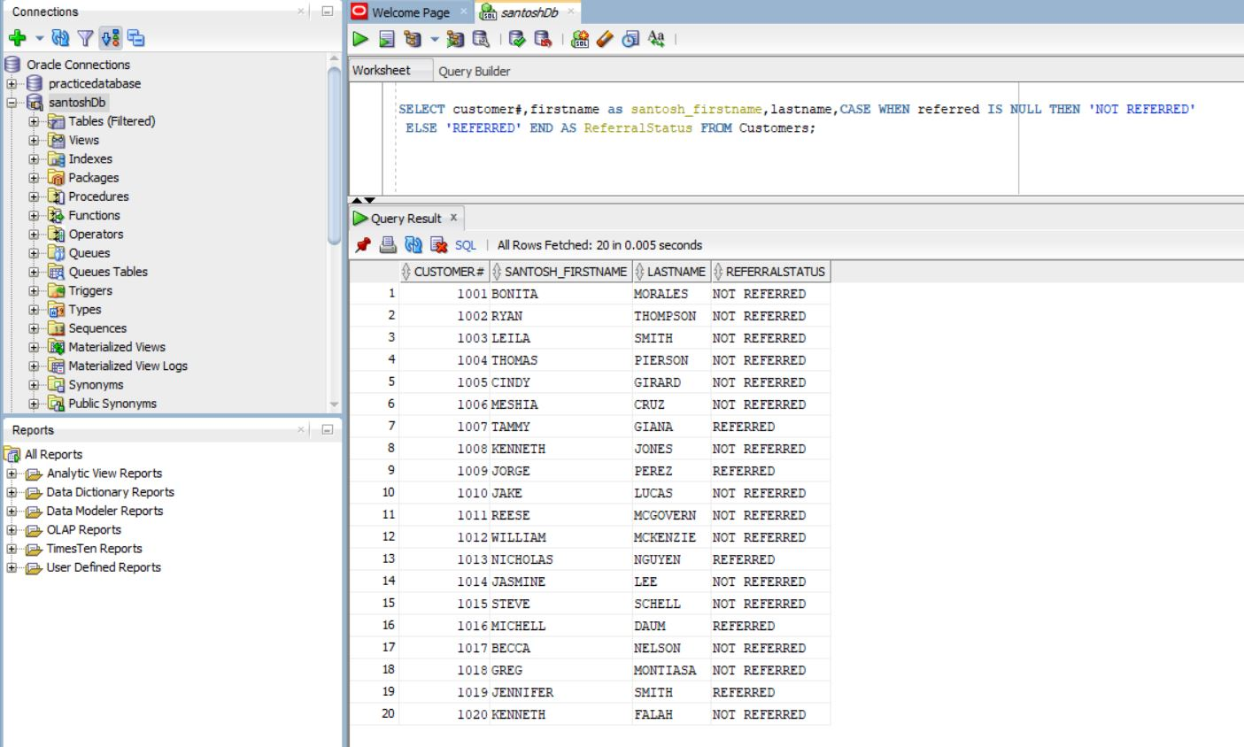

**3. Display a list of all book titles and the percentage of markup for each book. The percentage of markup should be displayed as a whole number (that is, multiplied by 100) with no decimal position, followed by a percent sign (for example, .2793 = 28%). (The percentage of markup should reflect the difference between the retail and cost Sagara Samarawickrama | 2023W amounts as a percent of the cost.) of markup should reflect the difference between the retail and cost amounts as a percent of the cost.)**

* CONCAT is the function in the sql that is use to connect the string or the character in the SQL.
* ROUND is use to remove the floating value in the SQL. Round is the inbuilt function in the SQL.

**SQL query**

* select title as santosh_title, CONCAT(ROUND(((RETAIL-COST)/ COST)*100), '%') AS "MARKUP PERCENTAGE" from books;

**Screen Shot of Sql**

Output

SQL Query

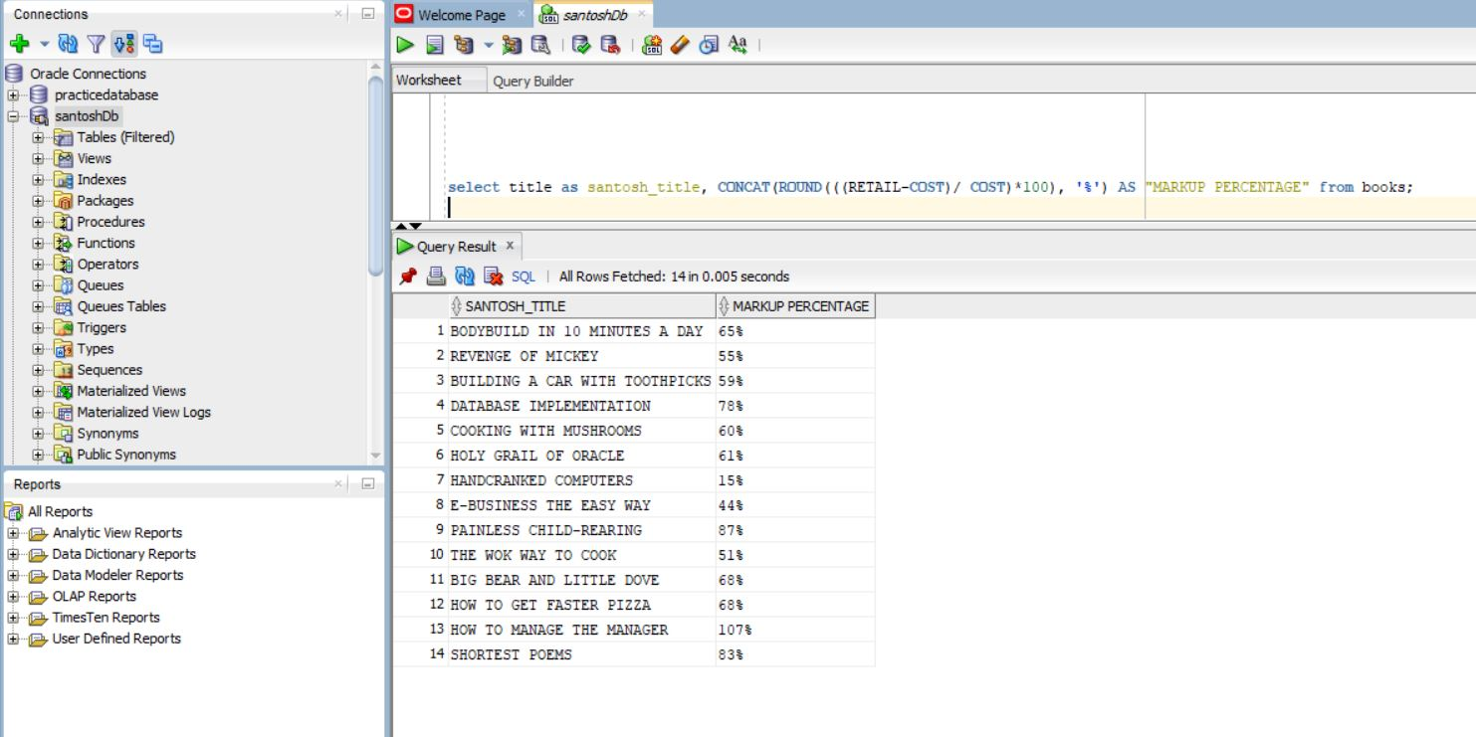

**4. Display the current day of the week, hour, minutes, and seconds of the current date**

**setting on the computer you’re using.**

* TO_CHAR is use to change the value in the character form in the SQL.
* SYSDATE is the system date that is provided through the computer.
* DUAL is the table that oracle has within it. It is kind of dummy table.

**SQL query**

* SELECT TO_CHAR(SYSDATE, 'DAY')||','||TO_CHAR(SYSDATE, 'HH24:MI:SS') AS santosh_CurrentDate FROM DUAL;

**Screen Shot Of the SQL Query**

Output

SQL Query

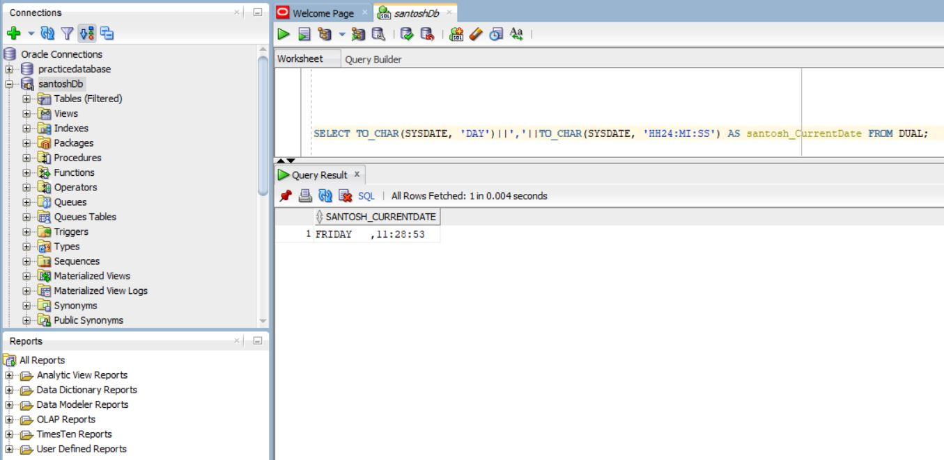

**5. Create a list of all book titles and costs. Precede each book’s cost with asterisks so**

**that the width of the displayed Cost field is 12.**

* LPAD is the function that is use for left padding the string with another string.
* It use three parameter string, length and lpad string. Where lpad string is the string required to be left pad

**SQL Query**

* SELECT title as santosh_title, LPAD(CONCAT('*', cost), 12, '*') AS Cost FROM books;

**Screen Shot of the Query**

Output

SQL Query

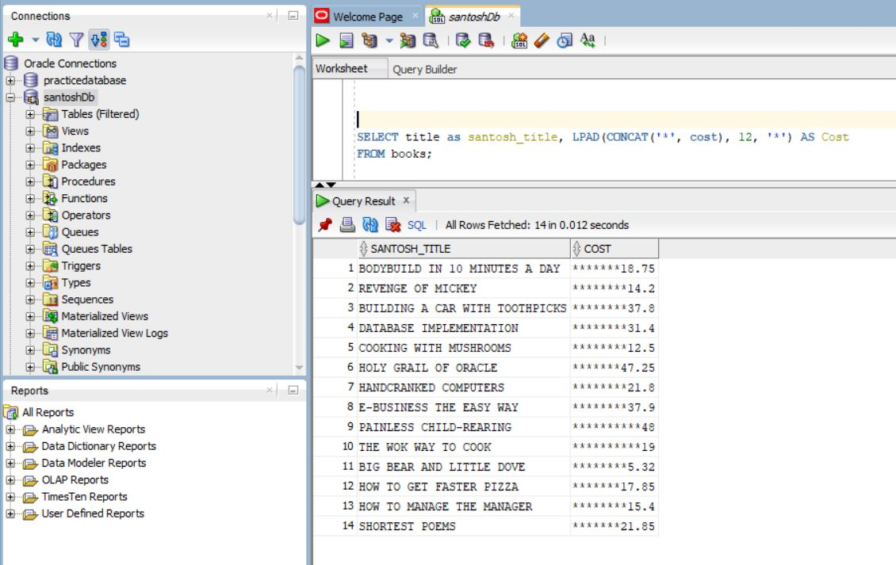

**6. Using today’s date, determine the age (in months) of each book that JustLee sells. Make sure only whole months are displayed; ignore any portions of months. Display the book title, publication date, current date, and age6.**

* Month between is the function that return the estimated number between date 1 and date 2.
* Round is used to round-off the decimal value in the query.

**SQL Query**

* SELECT title as santosh_title, pubdate,SYSDATE AS current_date, ROUND(MONTHS_BETWEEN(SYSDATE, pubdate)) AS age FROM books;

**Screen Shot of the Output**

Output

SQL Query

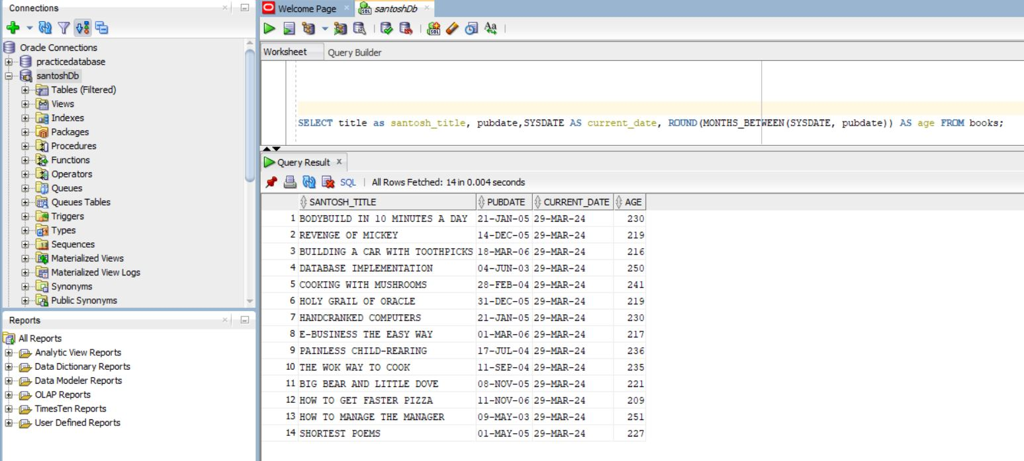

**7. Determine the calendar date of the next occurrence of Wednesday, based on**

**today’s date.**

* NEXT_DAY is the function used to determine the upcoming date from the current system date.
* It will take the two parameter with in it.
* It is also built in function in the sql

**SQL query**

* SELECT NEXT_DAY(SYSDATE, 'WEDNESDAY') AS "Santosh_Next Wednesday" FROM DUAL;

**Screen Shot of the SQL**

Output

SQL Query

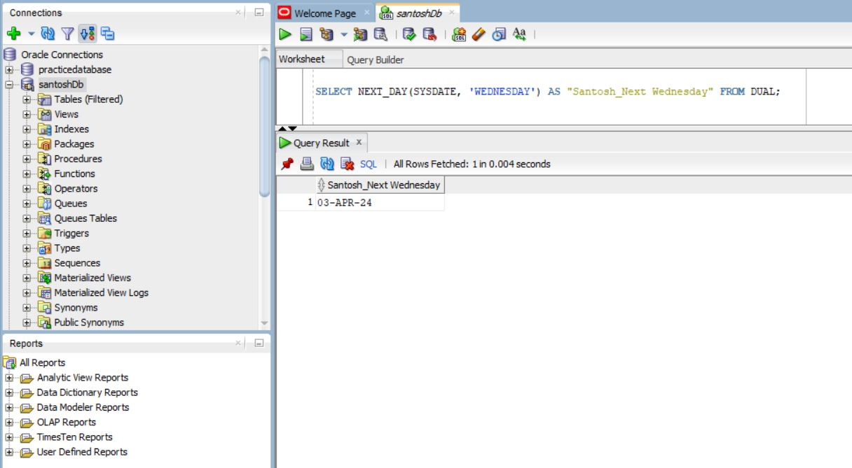

**8. Produce a list of each customer number and the third and fourth digits of his or her**

**zip code. The query should also display the position of the first occurrence of a 3 in**

**the customer number, if it exists.**

* INSTR return the first occurrence of the position of the string in the another string.
* INSTR is the function of the SQL

**SQL Query**

* select customer#,zip,SUBSTR(zip, 3, 2) AS santosh_zip, INSTR(customer#, '3', 1, 1) AS santosh_position from customers;

**Screen Shot of the SQL**

Output

SQL Query

